Democracy and Greece’s Golden Age

Directions: Use Chapter 5, Section 3 (or pgs. 134-139) in your textbook to complete the following questions and activities.

- Who was Pericles and what was his plan for Athens, Greece?
  - –
  - -
- Illustrate Pericles’ vision for Greece in the thought bubble below:
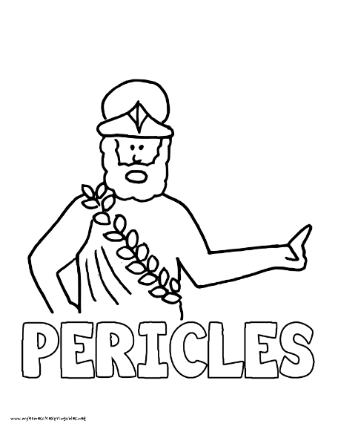

- What was the Parthenon and what was its purpose?
  - –
  - -
- Draw the Parthenon below. You can use your phone to look up a picture.
- Define classical art.
  - -
- What is the difference between a tragedy and a comedy? List an example of each.
  - –
  - –
  - -
- Who were the first two historians in Greek history?
  - –
  - –
- What were the causes of the Peloponnesian War?
  - –
  - –
- Who won the Peloponnesian War?
  - –
- What quote did Thucydides state to describe the outcome of the conflict?
  - -
- What is a philosopher?
  - -
- For each philosopher below, list their most important ideas. You need at least 3 ideas per philosopher.
Socrates | Plato | Aristotle

- Now that we are done with content for Greece, list at least 3 aspects of GREAT for Greece in the chart below: (use chapter five, sections one and two if you need additional information).
Government | -  -  -
Religion | -  -  -
Economics | -  -  -
Art/Architecture | -  -  -
Economy | -  -  -

