English and American Revolution

World History: Unit five

First 10:
- Why do you think the Haitian revolution followed the French?

- What caused these revolutions?

Key Concept: Absolutism +Enlightenment = Revolutions = Democratic forms of government

Road to Revolution:
- How did the Tudor dynasty end?

- Who is James I? What problems did people have with him?

- Who is Charles I? What problems did people have with him?

- What was the purpose of the Petition of Rights? Did it work?

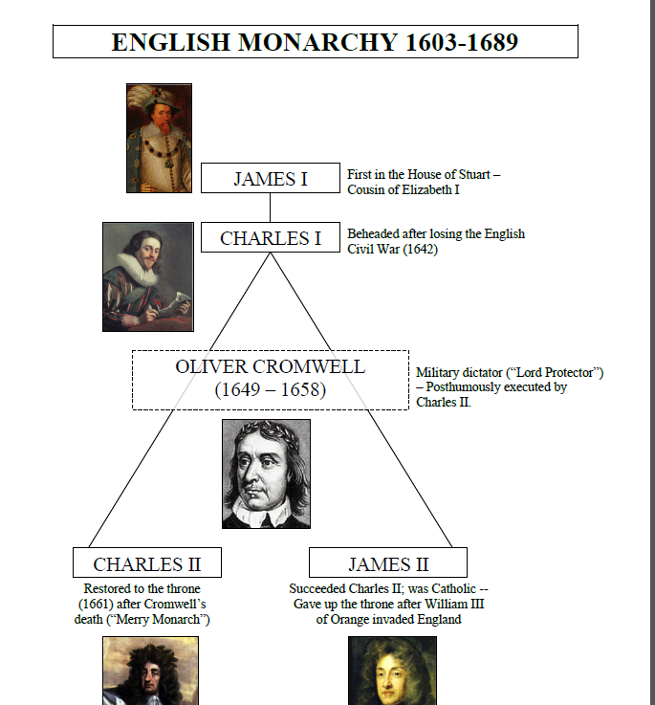
- The civil war was between who? What was the outcome?

- Who is Oliver Cromwell? What problems did people have with him?

- Who is Charles II? What is his reign called? Why?

Glorious Revolution:

- Causes:

- Why was it called a bloodless revolution?

- Effects:

American Revolution

Causes (explain) | Events (explain) | Effects (explain)

