Latin American Revolutions and Napoleon

World History: Unit five
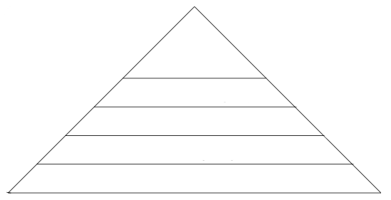First 10:

Causes (explain) | Events (explain) | Effects (explain)
Haitian Revolution:
Causes (explain) | Events (explain) | Effects (explain)
Latin American Revolution:

Napoleon Bonaparte:
Rise of Napoleon
Achievements
Fall of Napoleon

The Congress of Vienna:
Goal:
Major players:
Actions:
Results:

